Eg: Array_Eg3
// go through the code

Eg: Array_Eg4
//go through the code

Eg: Array_Eg5
int[][] n = {{1, 3}, {2, 4}};
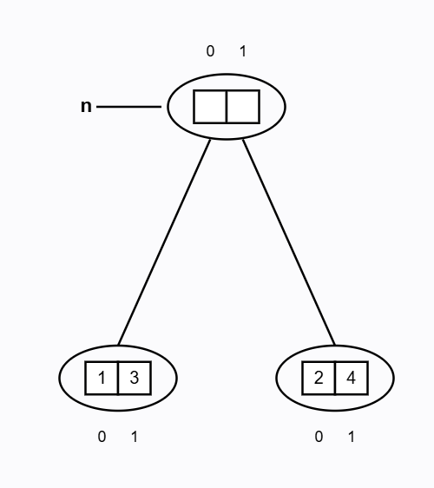

🧠 DRY RUN (WITH INTERNAL CONDITIONS — EXAM PERFECT)

Initial Setup
n.length = 2
So:
i = n.length - 1
i = 2 - 1 = 1

▶ OUTER LOOP – 1st ITERATION
i = 1
Check: i >= 0 → 1 >= 0 → true
So loop body executes.

Inner for-each loop
for (int y : n[1])
Row accessed:
n[1] → {2, 4}
for-each traversal (always LEFT → RIGHT):
y = 2 → print 2
y = 4 → print 4
Output so far:
2 4
Now:
i-- → i = 0

▶ OUTER LOOP – 2nd ITERATION
i = 0
Check: i >= 0 → 0 >= 0 → true
So loop body executes again.

Inner for-each loop
for (int y : n[0])
Row accessed:
n[0] → {1, 3}
for-each traversal:
y = 1 → print 1
y = 3 → print 3
Output so far:
2 4 1 3
Now:
i-- → i = -1

▶ OUTER LOOP – 3rd CHECK (STOP CONDITION)
i = -1
Check: i >= 0 → -1 >= 0 → false
Loop terminates.

✅ FINAL OUTPUT
2 4 1 3

Eg: Array_Eg6
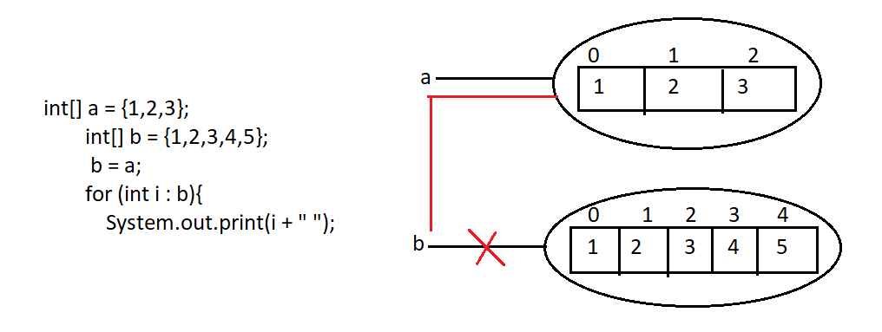
If b has more elements than a,
what happens if we write:
a = b;
Will Java give an error or not?

✅ SHORT ANSWER (INTERVIEW READY)
👉 NO error at all.
Java checks only the array TYPE, not the length.

🔁 Example Code
int[] a = {9, 8, 7}; // length = 3
int[] b = {1, 2, 3, 4, 5}; // length = 5

a = b; // perfectly valid

🧠 WHY NO ERROR? (CORE RULE)

🔑 Java Array Assignment Rule
During array assignment, compiler checks only the type (int[]),
length is checked at runtime only when accessing elements, not during assignment.
Both variables are:
int[] → SAME TYPE
So:
a = b; ✅ allowed

🧠 DRY RUN (MEMORY LEVEL)

▶ Before Assignment
Stack:
a → Array A (size 3)
b → Array B (size 5)
Heap:
Array A → {9, 8, 7}
Array B → {1, 2, 3, 4, 5}

▶ After Assignment
a = b;
Stack:
a → Array B
b → Array B
Heap:
Array B → {1, 2, 3, 4, 5}
👉 Old {9,8,7} array becomes eligible for GC
👉 No copying happens
👉 Only reference changes

⚠️ WHEN ERROR WILL COME? (VERY IMPORTANT)

❌ Runtime Error Case
a = b;
System.out.println(a[4]); // valid
System.out.println(a[5]); // ❌ ArrayIndexOutOfBoundsException
Because:
Array size = 5
Valid indexes = 0 to 4

❌ Compile-Time Error Case (TYPE MISMATCH)
int[] a;
double[] b;

a = b; // ❌ Compile-time error
Different types → not allowed

🏆 FINAL INTERVIEW GOLD LINE
👉 Array assignment in Java is based on type compatibility, not array length; length matters only during element access.

Eg: Array_Eg7
//go through the program

Eg: Array_Eg8
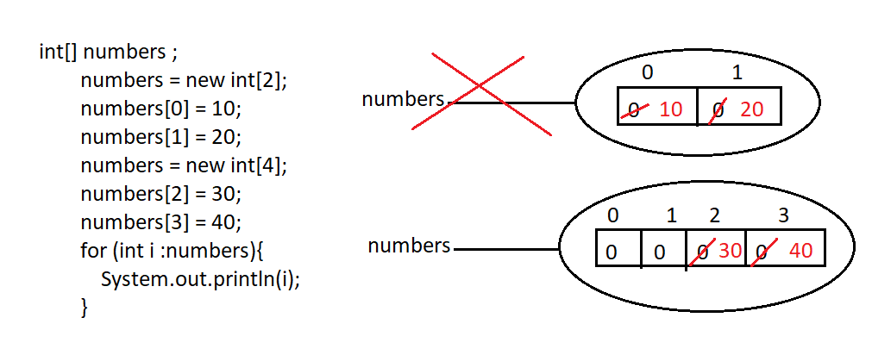
go through the code.

Eg: Array_Eg9
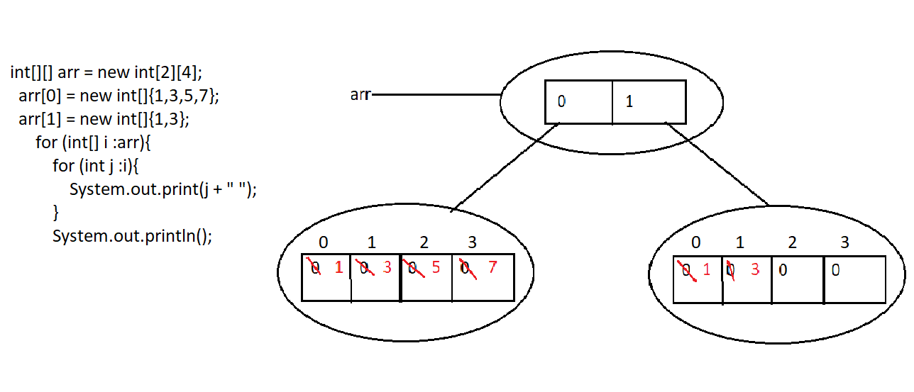

Eg: Array_Eg10
it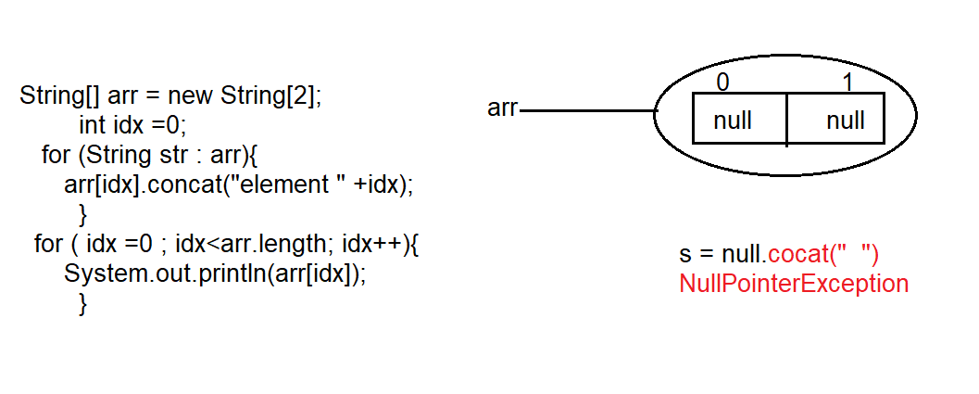
There is no element in the array and we are trying to use concat() method on it . it leads to NullPointerException.

If there are elements at location 0 and 1 then

🔁 Code we are talking about
String[] arr = {"hello", "pavan"};
int idx = 0;

for (String str : arr) {
arr[idx].concat("element " + idx);
}

▶ ITERATION 1 (WITH GC POINT)

Step 1: for-each picks first element
str = arr[0] = "hello"

Step 2: idx value
idx = 0

Step 3: Execute tricky line
arr[idx].concat("element " + idx)
→ arr[0].concat("element 0")
→ "hello".concat("element 0")
→ creates NEW String "helloelement 0"

Step 4: Return value
"helloelement 0" (returned)
❌ Not stored in any variable
❌ Not assigned back to the array
👉 Therefore:
"helloelement 0" → eligible for Garbage Collection
End of iteration 1:
Array = {"hello", "pavan"}
idx = 0

▶ ITERATION 2 (WITH GC POINT)

Step 1: for-each picks next element
str = arr[1] = "pavan"

Step 2: idx value
idx = 0 // unchanged

Step 3: Execute tricky line again
arr[idx].concat("element " + idx)
→ arr[0].concat("element 0")
→ "hello".concat("element 0")
→ creates NEW String "helloelement 0"

Step 4: Return value
"helloelement 0" (returned)
❌ Again not stored
❌ Again not referenced
👉 Therefore:
"helloelement 0" → eligible for Garbage Collection
End of iteration 2:
Array = {"hello", "pavan"}

▶ ITERATION 3
No
for-each ends because all elements are processed.

🧠 FINAL STATE
arr[0] = "hello"
arr[1] = "pavan"

🏆 FINAL GOLD LINE (PERFECT JVM LANGUAGE)
👉 Each call to concat() creates a new String object, and since the returned object is not referenced, it becomes eligible for garbage collection.

